APAO Handbook | California University  of  Pennsylvania
Academic
Program Assessment of
Outcomes

TABLE OF CONTENTS

what is Academic program Assessment of outcomes? 2

Completing the APAO plan report 4

Program Mission 4

CONTINUOUS ACADEMIC EXCELLENCE PLAN 5

EduCational Goals 7

Assessment Plan 8

Means of Assessment 8

Criteria for Success 10

completing the apao results report 12

assessment of results 12

use of results 14

instructions on submission of reports 17

appendices 19
A: Call for Service on APAC 20
B: Plan Report Template 22
C: Results Report Template 28
D: Bloom’s Taxonomy and Verb List 32
E: APAC Feedback Form 37

WHAT IS ACADEMIC PROGRAM ASSESSMENT OF OUTCOMES?
Throughout the year, California University of Pennsylvania faculty are engaged in a standardized assessment process to determine if students in their programs are actually learning what faculty identify the students should be learning. This practice is called Academic Program Assessment of Outcomes (APAO) and is part of the bigger process of assessment of institutional effectiveness. APAO is aligned with other academic reporting, such as the University strategic plan, department annual reports and five-year program reviews, and Middle States Accreditation.
Cal U has been conducting University-wide assessment of student learning outcomes since 1990. The Academic Program Assessment Committee (APAC), a University-wide APAO committee consisting of representatives from all units of the University community, coordinate the APAO process. They develop timetables, forms, the report evaluation rubric, and other useful materials. The committee also provides individualized assistance for program facilitators and evaluates the year-end reports. See Appendix A for the Call for Service that elicits membership to this committee.
Assessment of program outcomes is a two-step process – the plan and the results. Programs will be asked to submit two reports. The Plan Report (due in the fall) details the plan of action for assessing student-learning outcomes. Due in the spring, the Results Report will document the results of assessing student learning outcomes – what was found and what program faculty are going to do in response to the results to improve their program.

Timeline for completion of academic program outcomes assessment:
August – September | October | November | March | April | May
Department Meeting: create a mission statement, decide on outcomes to be measured, and plan of measurement | 10/1: Submit  Assessment Plan Report  to APAC  10/30: Notify APAC of significant changes | Adjust plan in response to APAC feedback  Collect data in introductory and/or capstone courses | Department Meeting: share results, plan to address findings to improve program | Close the loop: analyze data for meaning of results, and strengths and areas of concern  Identify strategies to address concerns  4/15: Submit  Assessment Results Report  to APAC | Adjust plan for improvement in response to APAC feedback  Include information in Annual Report

COMPLETING THE APAO PLAN REPORT
This part of the handbook provides guidance for completing the initial report to be submitted in the fall term (October) – the Plan Report. It might be helpful to have a copy of the template for this report (in Appendix B) as you read each section. The APAC will give you feedback on the Plan (see Appendix E for the Feedback form they will use). Your college coordinators (and members of the APAC) are available for consultation and guidance. Check the website for names and contact information (new link to go here once revised!).
PROGRAM MISSION
Every program offered at California University of Pennsylvania should have a distinct and specific philosophy or mission statement that reflects the program’s purpose and aligns with the mission statement of the University. The program philosophy/mission statement should be a broad statement that is more theoretical than measurable. It should reflect the ultimate goals of the program or department.
Cal U mission statement:
“The mission of California University of Pennsylvania is to provide a high-quality, student-centered education that prepares an increasingly diverse community of lifelong learners to contribute responsibly and creatively to the regional, national and global society, while serving as a resource to advance the region's cultural, social and economic development.”
CONTINUOUS ACADEMIC EXCELLENCE PLAN
Programs that have been conducting outcomes assessment can report past data that support their hypotheses for how to improve the program – make it excellent in compliance with the University’s mission of academic excellence. For example, if cumulative exams in courses required for the major resulted in students performing at or above established benchmarks (either the department’s defined criteria for success or external assessments for the careers in that major – say, a passing grade on the PRAXIS), the department could note that in this section of the Report. Then, the department describes a plan to investigate this supposition. For example, if cumulative exams in some required courses improved educational outcomes, then require all required courses to have cumulative evaluations and plan to collect data to confirm or refute this hypothesis.
Programs that are beginning their rigorous assessment of educational outcomes can still hypothesize what might be steps they could take to improve their program’s outcomes for student learning (steps toward excellence) and declare them in this section. They would then describe the plan for testing these suppositions via assessment of the outcome related to that supposition.
Example of Continued Academic Excellence Plan
In past outcomes assessment results, required courses that had a cumulative assessment during Finals Week evidenced significantly better student performance on educational outcomes than those that did not require a cumulative assessment.
ACTION ITEM: Require a cumulative assessment during finals week in all required courses.
As this is a re-organization of the major to a BS degree, there will be an increasing emphasis on the science of psychology in comparison to the BA degree requirements – despite only an increase of 3 credits required for the major.
ACTION ITEM: Compare previous assessments of science-based educational outcomes to assessment in the current plan for discovery if students are better able to think scientifically and evaluate information more critically.
As this is a reorganization, the assessment plan is also new.
ACTION ITEM: Evaluate the effectiveness, efficiency and value of this plan as stated below. Specifically, performance of the measures and the accuracy of the benchmarks.

EDUCATIONAL OUTCOMES
Educational outcomes declare the knowledge, skills, and dispositions/attitudes expected of graduates from the program and answer the following questions:
- What does the student know (knowledge)?
- What can the student do (skills)?
- What does the student care about (dispositions/attitudes)?
Educational outcomes relate directly to the discipline and are consistent with external standards. Outcomes should be related directly to the underlying foundations and skills of the subject matter pertinent to the program and department. The educational outcomes should also be consistent with external accrediting bodies.
Educational outcomes should be comprehensive and realistic. Educational outcomes for a department or program encompass the major expectations of graduates from the specific department and program, in broad terms. They are based on the honest expectations for the graduates of the program.
Educational outcomes are specific, measurable statements describing what graduates of the program are expected to know and be able to do. Each educational outcome is directly linked to the program content. The outcomes guide the choosing of assessment tools or means. Educational outcomes:
- are written in measurable terms. Bloom’s taxonomy (see Appendix D) can help define measurable terms that are appropriate for each objective.
- contain one measurable verb per objective. This allows for clear measurement of the outcome. (If there are more, the means of measurement should measure all verbs.)
- are short, easy to read, clear and concise.
  - Example of Educational Outcomes

III. Outcomes: Intended Student Learning Outcomes
EO. – 1. The student will be able to explain the foundational principles of legal theory and the nature of law.
EO. – 2. The student will be able to identify practices that generate conflicts of interest and/or are unethical.
EO. – 3. The student will be able to compare the differences in historical models of jurisprudence.

EO. – 4. The student will correctly apply the law to a fact pattern in order to resolve the legal question.

Objectives are program-specific
Only one measurable verb per objective
Use of Bloom’s taxonomy for measurable verbs

ASSESSMENT PLAN
The assessment plan section of the Plan Report is a detailed account of the plan for measuring the outcomes. Each outcome is assessed by 2 different measures.

Means of Assessment
Each outcome is measured in two different ways, that is, by two different “means of assessment.” The means of assessment must clearly measure the indicated learning outcome.
Assessments can be embedded in courses as assignments or tests, which is convenient for gathering and analyzing data. Assessments can also be standardized tests, comprehensive exams or licensure exams, or just about any method of measurement that best (valid and reliable) captures the amount of student learning that took place.
Assessments should provide quantitative data. This means that the assessments, when completed, should result in a number value. This can include a percentage, number correct, total points, or number of students that chose a specific item. If a rubric is used, it will need to have a number value associated with the scoring categories. Course grade point averages (GPAs), letter grades and overall GPA should not be used. The reason is that letter grades and GPA are not exclusively reflective of absolute student learning in the program. Sometimes they are curved, affected by bonus/extra credit allowances and other non-essential influences.
While two means of assessment are required, one of them should be an objective/direct assessment. The second method of measuring the educational outcome may either be objective/direct or subjective/indirect. An objective measure is one that is free from opinion. Examples of objective measurements may be standardized tests, portfolio evaluations, and course assignments. Subjective measures are based on the opinions of the learner such as alumni surveys and exist interviews.
If rubrics are used to assess papers, portfolios, presentations, or other assignments, if possible, use two raters. Identify the rater(s) by their position/relationship to the University or department. If inter-rater reliability (the correlation between the raters’ scoring) is known, report it in the means of assessment section of the Plan Report.
Include all assessment measures, i.e., copies of surveys, rubrics, assignment instructions, and/or information about standardized tests in the appendix of the Plan Report. Including the assessments allows for the APAO committee to fully understand assessments that are outside of their field of expertise.
NOTE: If, in the course of gathering data, the plan changes significantly (change in the selection of the learning outcome to measure, use of a different means of measurement, change in the definition of the criterion of success, or selection of the population of students to measure) send a REVISED Plan Report that includes an explanation for the change(s) to the APAC for review and feedback.
  - Possible Means of Assessment:

Objective Means of Assessment
- Comprehensive examinations
- Performance demonstration for graduating seniors
- Written proficiency exams
- National Major Field Achievement Tests
- Graduate Record Exams
- Certification examination, licensure examinations
- Locally developed pre- and post- tests
- Senior thesis / major project
- Portfolio evaluation
- Reflective journals
- Capstone courses assessments
- Internship evaluations
- Grading with scoring rubrics
- Graduate school acceptance rates

Subjective Means of Assessment

- Surveys of graduating seniors
- Exit interviews of graduating students
- Alumni Surveys
- Focus group discussions
- Employer Surveys
- Internship Supervisor Surveys

Criteria for Success
Declare a criterion for success for each means of assessment. It is the level of achievement by students that reflects the program’s effectiveness in teaching students. The criterion should state how many of the students will achieve a specific level on the assessment. Criteria should be stated in concrete, measurable, and quantitative terms.
The level of achievement on the assessment as established by the criterion for success should reflect the requirements of any accrediting bodies, the high standard of education that is required by the University’s mission statement, and the competitive nature of the occupational fields that graduates will be entering when they leave the University. The criterion for success or level of achievement must be stated in numeric measures such as percentage correct, or average.
The number of students that need to attain a criterion of success or level of achievement should reflect the University’s dedication to both excellence in education and to its students. It is important for the criteria for success to reflect expectations. A criterion should be an honest indicator of students successfully demonstrating that they have mastered the skills and knowledge required from the program. Setting a criterion at an aspirational level challenges a department to ensure that the students are given every opportunity possible to gain the knowledge, skills, and dispositions needed to be successful.
The number of students who are to attain the level of achievement may be stated in percentage of all students taking the assessment, percentage of respondents, or a specific number of students in programs that limit their enrollment. The number of students may also be stated in a whole group average, stating that the scores of all students taking the assessment must average a certain percentage or higher.
  - Examples of Means of Assessment and Criteria for Success
Outcome
1. Program graduates will exemplify counselor professional identity
Means of Measurement | Criterion for Success
Counselor Preparation Comprehensive Exam (CPCE) Professional Identity Score | 80% of all students will score within one standard deviation of the national mean of the Counselor Preparation Comprehensive Exam (CPCE) Professional Identity Subtest
Students will submit a Map Portfolio. The Department Outcomes Assessment Committee will evaluate the portfolio utilizing a rubric (see Appendix). Inter-rater reliability is .76. | 85% of all students will score an 80% or better on the rubric (raters’ scores will be averaged for each student).

Inter-rater reliability and the raters are identified
Reports percentage of students to achieve the criteria for success
Measure yields quantitative data

Score is at the level of excellence set by the University
Information about the CPCE (validity, reliability, and example questions) will be listed in the appendix

COMPLETING THE APAO RESULTS REPORT

This part of the handbook provides guidance for completing the year-end report to be submitted in the spring term (April) – the Results Report. It might be helpful to have a copy of the template for this report (in Appendix C) as you read each section. The first part of the report is a repetition of the Plan Report so the readers on the APAC are oriented to the program’s mission and plan of assessment. Add the Results Report to your Plan Report for submission (see Instructions for Submission section). The APAC will give you feedback on the Results Report (see Appendix E for the form they will use).

Assessment Results
The discussion of assessment results should describe data collection and analysis.

Data Collection
Collecting data can be done in several ways. Using the Desire2Learn system, instructors are able to collect data for assessments that are completed using the system. Alternatively, data can be collected in an Excel spreadsheet format. Some departments have specific tools that are designed to collect and store the data from assessments and assignments completed by the students, such as LiveText.
Data should be collected from all students completing the assessment, as specified by the criterion for success. This may mean sorting some students out or integrating the data from several classes in the program. For instance, if the assessment is being given in a course where there may be students from other majors or programs, or students of different grade levels, it is necessary to filter their data out.

Data Analysis
In order to analyze the data, it is important to fully understand what the criterion for success is looking for. If the criteria for success is that 80% of the students will achieve a specific grade, it is necessary to know the number of students that are taking the assessment, what 80% of that number is, and if that specific number of students achieved that level.
In order to accurately analyze the data, certain information needs to be known (depending on how the criterion for success is defined):
- the number of students taking the assessment
- the grade, in numeric form, that each student received on the assessment
- the level of achievement that is required for meeting the criterion of success
- the number or percentage of students required to meet that level of achievement
- the mean or average of all of the grades
- the standard deviation for the grades
It is important to include the means of assessment and criterion of success in the Results Report so that the APAO Committee understands the benchmarks being used to assess the outcomes of the program.

Results
When reporting the results, use as much relevant data as possible. This will increase the validity of the results being used in the report. The results should use all available and appropriate data, rather than just samplings of the data. To quantify the results, report the sample size and other appropriate descriptive statistics. For example, if the criterion for success was defined as “80% of students will score within one standard deviation of the mean,” then the mean and standard deviation need to be reported. Do not include any raw data (or any student identifiers such as names or CWID) in the report.
Report the results in the same terms as the criterion for success. To do this, report the criterion for success with either the number of students or the level of achievement, depending on the results. Include a statement regarding the achievement of the criterion for success. This is a simple sentence that states either the criterion for success was met or the criterion for success was not met.
  - Example of Assessment Results

Assessment Results
For the overall assessment of this competency in Advanced Field Education, 94.7% (18 out of 19 students) achieved a rating of 4 or higher. The mean score for this assessment was 4.21667 with a standard deviation of .3329.

The criterion for success was met.

Level of achievement restated

Percentage of students that achieved level of success is stated. Included is the number of total students taking the assessment (n value)

Standard deviation is reported

Mean score is reported

Simple statement of whether the criterion for success was met

Use of Results
Using assessment results to make program modifications and adjustments is what the Middle States Commission on Higher Education refers to as “closing the loop.” This critical step in the APAO process helps program faculty make the necessary changes to improve student learning outcomes.

In order to complete this section, all program faculty should be involved in a discussion of the assessment results. It may be beneficial to state when and how the faculty discussed the results, such as “at a department meeting.” Discussing the results as a department reinforces the idea that outcomes assessment is a departmental responsibility. It will also allow for the generation of ideas to improve or maintain the results.
If results meet the criterion of success, faculty might consider a plan to maintain the success. When benchmarks have not been met, address how the program can be modified to help students meet the benchmark. This plan can also include ways in which the department will attempt to raise the criterion of success by either increasing the number of students required to attain the achievement level or by raising the achievement level itself, especially if a large majority of the students are achieving it.
If results do not meet the criterion of success, report how the department will respond. This can include an outlined plan of curriculum changes, increased emphasis on the learning outcome, or more time given to practice the outcome prior to the assessment.
Report a plan for assessing the impact of the changes made in response to the data gathered on student learning. For example, re-assessing the same learning objective in the coming year as the last year to be able to quantify the impact of the change made (either in curriculum, practice time extension, increasing the criterion of success, or some other intervention). This is the start of the plan for fall’s submission of the next Plan Report. By necessity, there is repetition in this process to capture the cyclic nature of program evaluation (called “closing the loop”).

  - Example of Use of Results

Use of Results:
The faculty and staff reviewed the data and results as part of the departmental meeting where strengths, weaknesses, and the need for changes were identified. The data will also be reviewed at TEAM day.
The department is not surprised to see the students rating themselves slightly higher than the faculty did. The data showed a discrepancy in how the students rated themselves in the area of classroom management and partnerships, when compared to the faculty members. Students identified assessment as the strongest area for the group, which did not match the faculty’s viewpoint. The department feels that the faculty needs to make students more aware of the strengths that are seen in certain areas and make expectations clearer. This will be accomplished through increased written positive feedback for students in the program and clarification in areas such as rubrics and classroom objectives.

APPENDIX A:
Appendix A should include a copy of all the assessments used in the current years report. This can include copies of the surveys, rubrics, assessments and information given on standardized tests that cannot be included in the report due to copyright issues.
Include labels that allow readers to know which assessment goes with which objective being measured.
APPENDIX B:
Appendix B is set up exactly like the actual report, but without the results and use of results sections. This means that the objective to be measured must be stated, the means of assessment that will be used must be stated and included and the criteria for success must be stated. Include the copies of the assessments at the end of the Appendix.

Briefly discusses the meaning of the results and how they are interpreted by the department
Discusses changes to be made in the future to improve or increase the success rate
Includes discussion of department

INSTRUCTIONS ON SUBMISSION OF REPORTS
The Plan Report and the Results Report should be submitted as paginated PDF documents that include the actual report and, in the case of the Plan Report, an appendix containing a copy of the actual measures that are used as means of assessment.
Reports should only include the information for one program. There may be departments that have multiple programs that share a core of required courses with some individual courses (example: Biology and the pre-medical professions). The APAO committee will work with units and faculty to streamline the assessment process.
Label the document using the following convention:
CatalogNamePrefix_PlanReportYear_ProgramName_LastName
Or
CatalogNamePrefix_ResultsReportYear_ProgramName_LastName
  - Example for Formatting the Report

CED_PlanReport2013_GraduateSchool_Smith
Report Type and Year
Last Name of Report Writer
Department Name
Catalogue Name of Program – Three Letter Initial

To Submit a report to the APAO Committee:
- Save as ONE pdf with report first and assessment tools in appendices after the report
- With the document open, click “Save as” and
- Click on your computer address at the bottom of the list of files on the left of your screen:

- A dialog box appears with drives and files listed, click on the “UniversityDrive”:
- Click on OutcomesAssessment Folder:
- Find the appropriate folder for your report, click on it to open and save there:

Appendix
- A: Call for Service on APAC
- B: Plan Report Template
- C: Results Report Template
- D: Bloom’s Taxonomy and Verb List
- E: APAC Feedback Form

APPENDIX A
CALL FOR SERVICE
CALIFORNIA UNIVERSITY OF PENNSYLVANIA
ACADEMIC PROGRAM ASSESSMENT COMMITTEE (APAC)
Cal U, in order to provide a “high-quality, student-centered education that prepares an increasingly diverse community of lifelong learners to contribute responsibly and creatively to the regional, national and global society, while serving as a resource to advance the region's cultural, social and economic development,” (Mission Statement 2020), seeks to establish a relevant, effective system of assessing student learning outcomes. Toward that end, we seek qualified committed faculty to serve on the University Wide Academic Program Assessment Committee.
Some experience of and knowledge in assessment of student learning outcomes is needed as well as an ability to guide colleagues (across campus) in the process of assessing student learning outcomes. Additionally, selections will be made in order to provide equal representation of all four colleges (Liberal Arts, Education and Human Services, Science and Technology and Graduate School and Global On-Line).
- Work with college deans and department chairs to identify and empower program Assessment Coordinators.
- Assist with the development of college, department, and program mission statements aligned with the Academic Affairs mission statement.
- Promote the development of academic program learning goals with measurable discipline and student achievement learning outcomes.
- Promote effective college-wide program assessment processes, which include annual documented data-based decision meetings designed to improve student achievement.
- Promote a standard “Assessment Update” agenda item for all department meetings where program faculty and/or Assessment Coordinators frequently discuss assessment progress and/or milestones.

This is a service position, so it will be documented and can be cited in the faculty member’s tenure and promotion dossier. Three-year terms are expected, with re-nomination invited to committed members.
Complete the second page and return to:
Dr. Len Colelli (Associate Provost/Associate Vice President for Academic Affairs) at colelli@calu.edu
or
Dr. Steve Atkins (Director of Institutional Effectiveness) at atkins@calu.edu

NAME: _____________________________________________________________
DEPARTMENT: _______________________________________________________
COLLEGE: ___________________________________________________________
Please briefly describe your experience with assessing student learning out comes at the program level:

Please briefly describe your experience with guiding colleagues through processes or procedures (some examples might be workshop facilitation, departmental committee leadership, etc.):___

Thank you so much for your desire to serve!

APPENDIX B
California University of Pennsylvania
Office of Assessment and Accreditation
PLAN REPORT
Instructions: Use this template to report your program’s mission, educational outcomes, and plan of assessment (which includes two means of measurement for each outcome to be assessed this year, and the criterion of success for each measure). Answer all the questions for each outcome you plan to measure. The APAC will assist you with all parts of this task!
College
Program
Contact Name
Email
Academic Year
Program Mission
Complete as many of the following boxes as you need to that reflect your plan for assessment THIS YEAR, delete the rest.
Continuous Academic Excellence Plan
1 Educational Outcome to be measured this year
Relationship to the University Mission/Strategic Plan (check all that apply)
☐Enhance academic excellence
☐Operate with sound and efficient fiscal and governance practices
☐Create a learning and working environment that promotes diversity, civility, and inclusiveness
☐Promote and provide public service
☐Enhance the quality of student life

Means of Measurement |  | Criterion for Success
1:
2:
2 Educational Outcome to be measured this year
Relationship to the University Mission/Strategic Plan (check all that apply)
☐Enhance academic excellence
☐Operate with sound and efficient fiscal and governance practices
☐Create a learning and working environment that promotes diversity, civility, and inclusiveness
☐Promote and provide public service
☐Enhance the quality of student life

Means of Measurement |  | Criterion for Success
1:
2:
3 Educational Outcome to be measured this year
Relationship to the University Mission/Strategic Plan (check all that apply)
☐Enhance academic excellence
☐Operate with sound and efficient fiscal and governance practices
☐Create a learning and working environment that promotes diversity, civility, and inclusiveness
☐Promote and provide public service
☐Enhance the quality of student life

Means of Measurement |  | Criterion for Success
1:
2:
4 Educational Outcome to be measured this year
Relationship to the University Mission/Strategic Plan (check all that apply)
☐Enhance academic excellence
☐Operate with sound and efficient fiscal and governance practices
☐Create a learning and working environment that promotes diversity, civility, and inclusiveness
☐Promote and provide public service
☐Enhance the quality of student life

Means of Measurement |  | Criterion for Success
1:
2:
5 Educational Outcome to be measured this year
Relationship to the University Mission/Strategic Plan (check all that apply)
☐Enhance academic excellence
☐Operate with sound and efficient fiscal and governance practices
☐Create a learning and working environment that promotes diversity, civility, and inclusiveness
☐Promote and provide public service
☐Enhance the quality of student life

Means of Measurement |  | Criterion for Success
1:
2:
6 Educational Outcome to be measured this year
Relationship to the University Mission/Strategic Plan (check all that apply)
☐Enhance academic excellence
☐Operate with sound and efficient fiscal and governance practices
☐Create a learning and working environment that promotes diversity, civility, and inclusiveness
☐Promote and provide public service
☐Enhance the quality of student life

Means of Measurement |  | Criterion for Success
1:
2:
7 Educational Outcome to be measured this year
Relationship to the University Mission/Strategic Plan (check all that apply)
☐Enhance academic excellence
☐Operate with sound and efficient fiscal and governance practices
☐Create a learning and working environment that promotes diversity, civility, and inclusiveness
☐Promote and provide public service
☐Enhance the quality of student life

Means of Measurement |  | Criterion for Success
1:
2:

APPENDIX C
California University of Pennsylvania Office of Assessment and Accreditation
RESULTS REPORT

Attach the following document (completed) to your Plan Report and submit as ONE Document.
Complete as many boxes as necessary and delete any you do not use.
EDUCATIONAL OUTCOME 1
RESULTS (Numerical summary: sample size, means, standard deviations, percentages, etc.)
ANALYSIS (Statement regarding criterion of success and any additional information you gleaned as a result of the measure)
ACTIONS (What are you going to do in light of this assessment?)

EDUCATIONAL OUTCOME 2
RESULTS (Numerical summary: sample size, means, standard deviations, percentages, etc.)
ANALYSIS (Statement regarding criterion of success and any additional information you gleaned as a result of the measure)
ACTIONS (What are you going to do in light of this assessment?)

EDUCATIONAL OUTCOME 3
RESULTS (Numerical summary: sample size, means, standard deviations, percentages, etc.)
ANALYSIS (Statement regarding criterion of success and any additional information you gleaned as a result of the measure)
ACTIONS (What are you going to do in light of this assessment?)

EDUCATIONAL OUTCOME 4
RESULTS (Numerical summary: sample size, means, standard deviations, percentages, etc.)
ANALYSIS (Statement regarding criterion of success and any additional information you gleaned as a result of the measure)
ACTIONS (What are you going to do in light of this assessment?)

EDUCATIONAL OUTCOME 5
RESULTS (Numerical summary: sample size, means, standard deviations, percentages, etc.)
ANALYSIS (Statement regarding criterion of success and any additional information you gleaned as a result of the measure)
ACTIONS (What are you going to do in light of this assessment?)

EDUCATIONAL OUTCOME 6
RESULTS (Numerical summary: sample size, means, standard deviations, percentages, etc.)
ANALYSIS (Statement regarding criterion of success and any additional information you gleaned as a result of the measure)
ACTIONS (What are you going to do in light of this assessment?)

EDUCATIONAL OUTCOME 7
RESULTS (Numerical summary: sample size, means, standard deviations, percentages, etc.)
ANALYSIS (Statement regarding criterion of success and any additional information you gleaned as a result of the measure)
ACTIONS (What are you going to do in light of this assessment?)

SUMMARY (Optional: Discuss any overarching conclusions you have come to and anything you want the APAC to know in understanding your report)

APPENDIX D
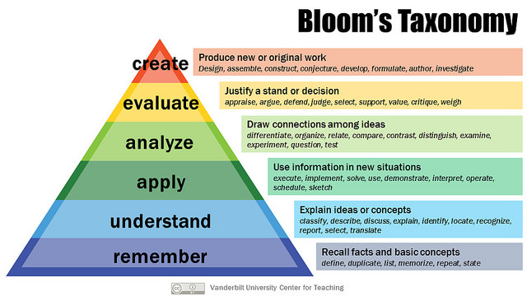As students advance through a program, they are expected to accomplish more demanding task demands (going up the pyramid). The following are verb lists that can be used in educational outcomes to reflect that level of expected student achievement in your program.
SOURCE: https://sijen.com/tag/knowledge-wheel/

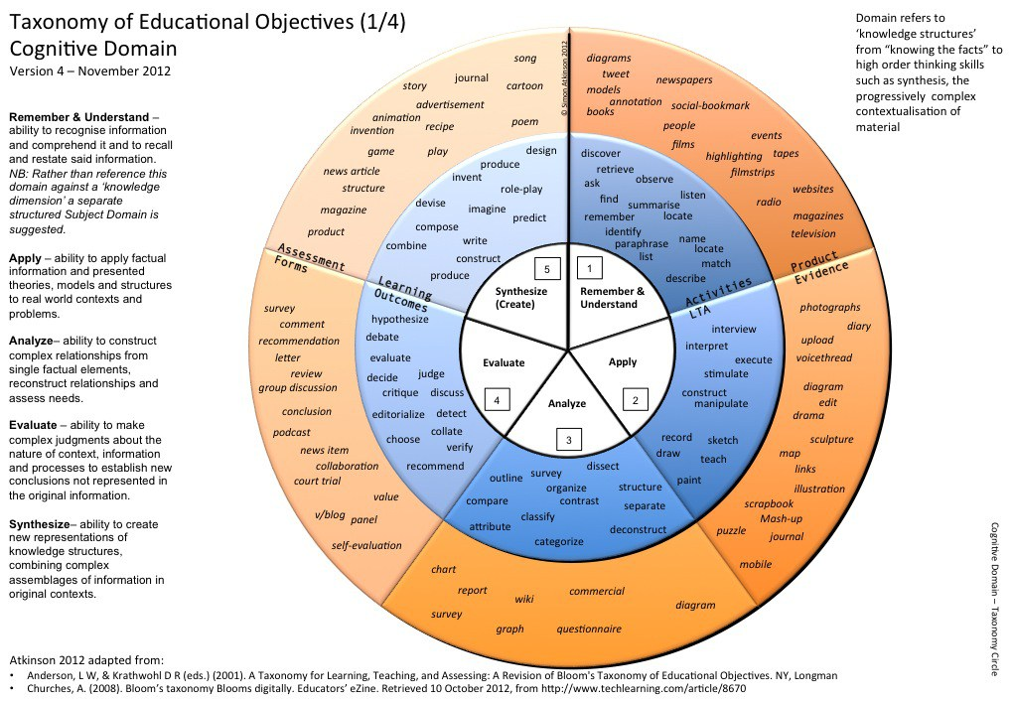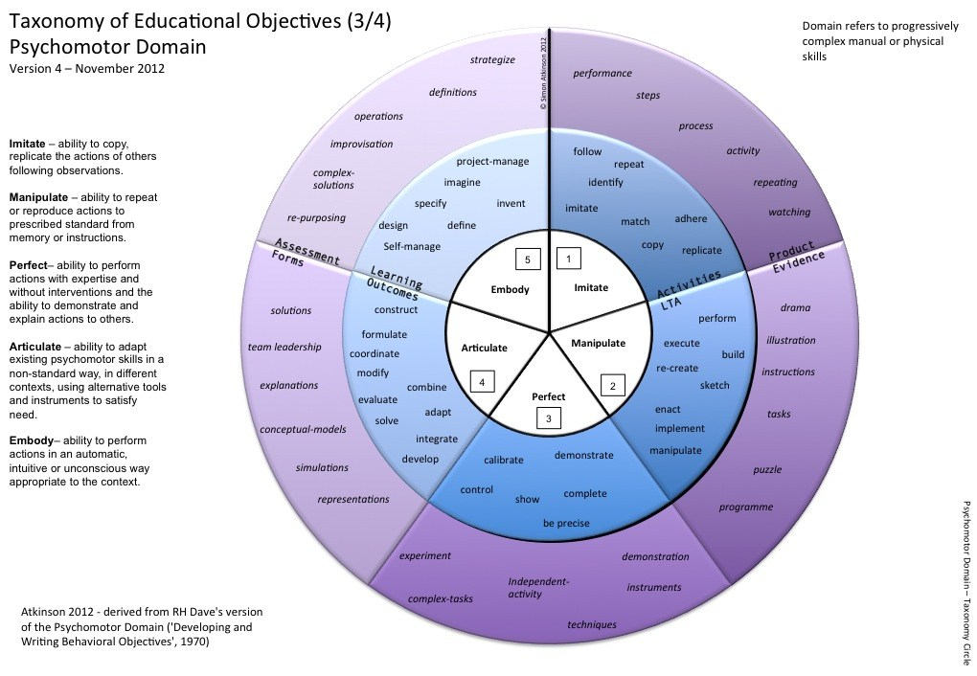
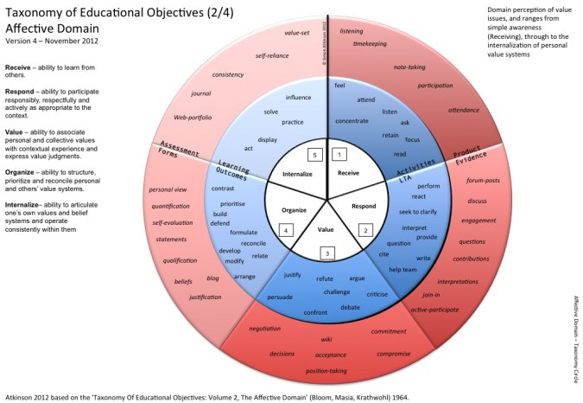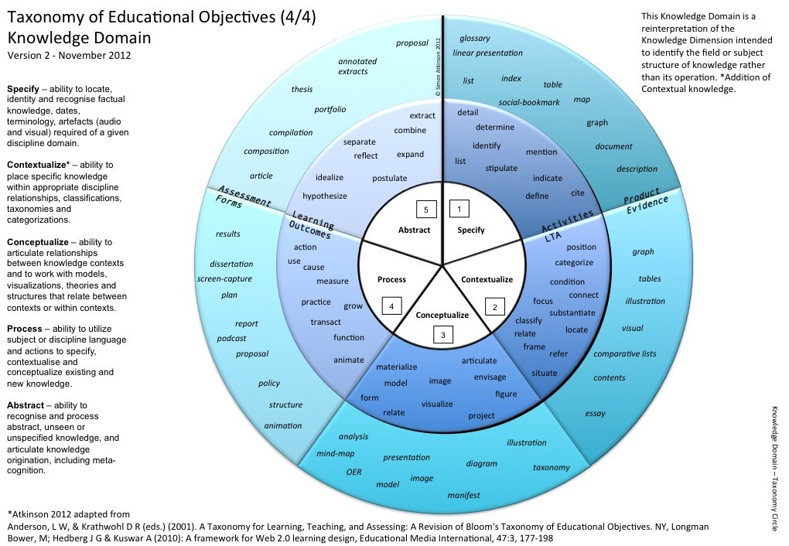
APPENDIX E
APAC FEEDBACK FORM
Level of Feedback | Acceptable | Needs Work | Unacceptable | Missing
Educational Outcomes | - Reflect mission and content of program  - At level of rigor for program  - Use measurable verbs  - Exhaustive of program content
Comments:
Methods of  Measurement | - Reflect the content of the outcome  - Measure ALL verbs in the outcome  - Valid  - Reliable  - Not grades or GPA
Comments:
Criteria for Success | - Reflect the level of excellence expected at Cal U  - Are consistent with the measure  - Result in quantitative data
Comments:
Action Plans from Results | - Are connected to the data  - Are reasonable  - Are actionable  - Impact can be measured  - Reflect the goal of quality improvement
Comments:

APAC MEMBERS:

